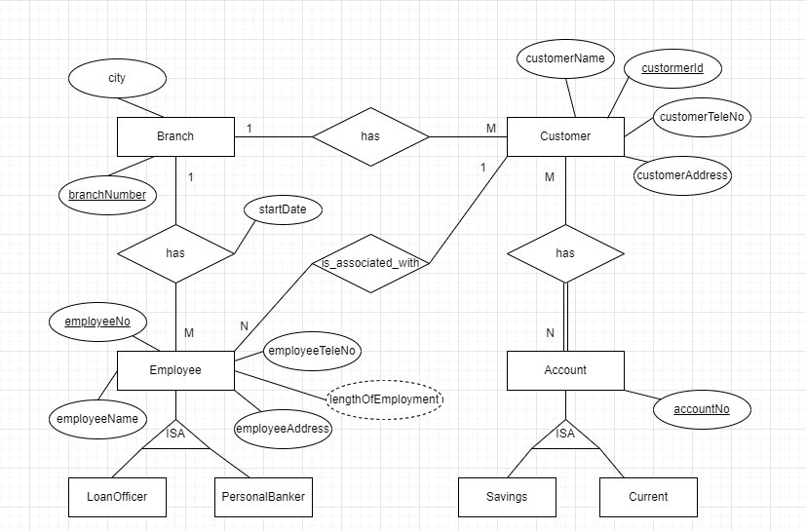

**Assumptions**

* Assumed that one customer belongs to only one branch.
* Assumed that one employee works only for one branch.
* Assumed that one employee (loan officer, personal banker) is an associate of only one customer.